The report should be between 5 and 7 pages long

1: Introduction and problem statement
«What problem are you trying to solve? Why is this important? How does this problem make some sort of game better? »

We wanted to make a board game dungeon map creator in this project. Having rooms, doors, items and interactables being procedurally generated on the fly, as we journeyed through the dungeon. Our idea was to create this in a way that utilized PCG in some sort of manner that would make the user feel like it was part of a “story” in some sense, or that everything had some sort of connection. This also meant that we wanted to give the user some sense of choice. Whether it was to possible directions to venture, or to have some sort of (History?) decision-point where the user would have to set the scene for how the next parts of the dungeon would be generated. A simple example we came up with was to have the player choose whether he or she felt adventurous or not. Using this information in order to toggle if the dungeon should have a lot of bends and be made very spread, or if it should be more linear and maybe shorter.

Our problem statement was formed to be something like this:
- Procedurally generate a dungeon and it's contents in real-time, as the player explores what is already generated. Making points along the way where enemies, treasure or other points of
interest can be found and interacted with.

Initially we wanted to create something really big. Having the dungeon implement some sort of history. So say that if the player were to kill an enemy, the game would then know that that type of creature would act more hostile the next time the player would encounter them. And on the other side, if the player were to help that “enemy”, maybe it would become a friend instead?

If we wanted to implement this type of history and decision making into the generator, we would also have to find some sort of way to generate these options and decisions as the player progress through the dungeon.

In this document, we will elaborate and discuss on the implementations we made, how we narrowed down our scope in accordance with the supervisor, and how we came to the conclusions that we did.

2: Background
Has this been done before? How? If not, what's the closest related research? (Both using similar approaches and other algorithms.) What's novel with your research?

Procedural content generation for maps and dungeon creation has been used a multitude of time over the years. So what we wanted to do for our project, in order to hopefully make it stand out, was to try to implement the element of decisions and history. By having close to everything being generated as you go along, would make it possible to generate a huge amount of different scenarios, maps and game plays. Technically speaking, every play-through could be different.
Our goals and wants for this project was initially set very high, as we wanted to have the opportunity to implement as much of our vision as possible. How much we can implement, and how the scope may be narrowed down, remains to be seen.

There are plenty of concepts, ideas and pre-made generators out there, and it can be quite informative to look into those, read about how other people have made their solutions, and get ideas to how we can improve and make our project as good as we are able.

When our generator is complete, we are hoping to use some smart algorithms, like A-Star, in order to validate if our dungeons are viable. We will have to use this in-game as we generate as well, if we hope to create our maps “on the go” since we want the room placements to be dependent on how the player interacts with the world we create for them.

We believe that making this dungeon generator/exploration game will be an interesting project, as we will get to put our minds together to come up with what we hope will be great ideas as to how we can create fun and interesting dungeons. Will we be able to make the game as we visualize it, or will we end up with something completely different along the way?

3: Game Design
What's the design of the game you are going to use? Why do you need PCG in this game?

The core mechanics of the game are purely based on PCG. Without it, the game would simply not be possible. Of course, we could always create dungeons using manual design, and a paper-to-code approach. But since we want to make a game that is purely based on PCG, we need to create every algorithm from scratch, and we have to make calculated design approaches in order to make the algorithms as we want them.

Our first and foremost milestone, is to come up with a way of creating the dungeon in such a fashion that we can validate how good it is, and from there, make it so that we can add more features into it, like creating objects, enemies and other interactables.

Our approach to generating the dungeon, rooms and content in real-time, will be to first create a dungeon generator that will instantly create the entire dungeon in one go. That means all the rooms, doors and hallways. This means that we will have to come up with a clever way of making a complete layout of the generated content. Making sure that the sizes of the rooms don't exceed the total size of the map, and to enable the dungeons to be generated in different sizes and shapes. Just because we initially want to be able to create a complete dungeon, doesn't mean we always want to create the same one, as that would not really constitute the sort of procedural content generation that we want.
From there our task will be to break it down into pieces. Have only a single room be created from the start, and then expand on that room. Having one or more doors or ways to exit the room in different directions, and then generate new rooms that will be visible to the player.

Once we are able to generate a dungeon be creating new rooms and connecting them to the existing map, as the game is being played, the next step will be to have some form of content in the rooms.
The start point will, for the sake of simplicity and control, always be in the center of the first room that is created. But as we expand on our dungeon, we will need to have some sort of end condition. So what we will do is to implement an exit area. At first we thought about having the exit point be set from the start, and then create the rooms in the map so that they would eventually reach that point. But as we thought about it more and more, we realized that this was not how we wanted it. We wanted the players to explore as much as possible, without having to think about where the exact point of the exit were. So what we came up with, was to have the “adventure” scale. Basically what that means, is that the player gets the choice to select how “adventurous” he or she is feeling, and have that decision factor into the generation of the game space. If the player is feeling adventurous, the dungeons will be generated with rooms that spread more out, and that has more options of directions that are accessible. And going back to the end point; we believe the game would be more fun if the exit is generated suddenly, when you enter a new room that was previously unexplored. And when the exit would appear, would in some way be connected to how adventurous the player was.

With the ending condition now figured out, the thoughts on how we would generate other items in-game, like treasure, enemies, etc. arose. After brainstorming for quite some time, we came to the conclusion that these items and interactables should be dependent on the adventure-meter, but also be dependent on an element of luck and chance.
Creating rooms that were dead ends, could significantly increase the chance for an encounter of some sort to happen.

4: Methods
How does your algorithm work? Describe in as much detail as you can fit into the report. Classify your algorithm according to the taxonomy in the "Search-based Procedural Content Generation” paper. Also, how did you interface it to the game?

CreateBoard
CreateCenterRoom
CreateFitRoom
GenerateDoors

A-Star

Multitude of dungeon generation attempts: also to be continued in discussion and results.

etc etc

5: Results

«Did it work? How well? Provide some ﬁgures, and a table or two. How much time does it take? Remember to include signiﬁcance values (remember the t-test?), variance bars... Reread some of the papers from class and compare how they report their results.»

- Did it work
We weren't able to implement all the features that we wanted, and that were described in the introduction and background. Our original idea was too out of scope, with much too many goals that would be unreachable given the time we had for our project. Even though not all we wanted to do, was completed, we were able to implement the most important features; having a dungeon being created in real-time, allowing the players to explore the dungeons as they see fit. Whether they are feeling adventurous, or just want to have a quick map and be done with it.
By utilizing the A-Star algorithm, we are able to make the rooms get different “adventure”-values based on how far away from the start they are, how much the players have explored, and how adventurous they have been. The chance for a room to spawn more doors, and in turn, more opportunities for the player, are also based on the adventure-meter and the A-Star. If you for instance are far away from the start (have explored quite a bit), the chance to walk into a dead end are increased.

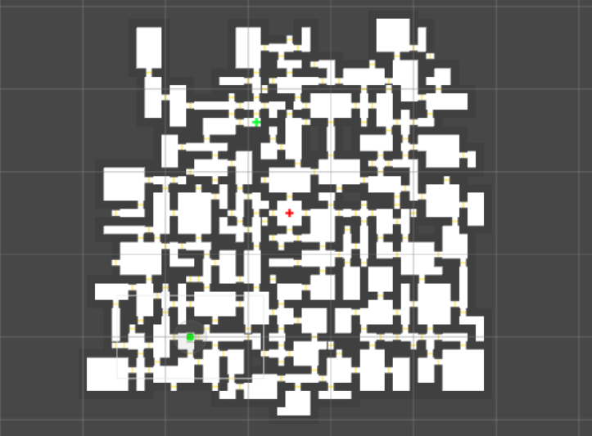
The win condition also is based on how adventurous the player is. If they are feeling like exploring a huge dungeon, then the end-point will not spawn until the map “feels” like it has offered a lot of options and diversity.

- How well

- How much time did it take

- Issues
* Misplacement of doors
* Overlapping of walls
* Too little time

6: Discussion

«What are the strengths and shortcomings of your method?
Why did you choose method X instead of Y?
How well would it generalize to other game genres?
How would you develop it further, if you had time?»

Further development:
NPC spawning.
NPC types, groups, interaction.
Better connections between doors/rooms/walls
Dungeon size reconfiguration

7: References

8: Acknowledgements

